
COMPUTER AND INFORMATION TECHNOLOGY DEPARTMENT
Africa Nazarene University Gate Management System

BY
BRANDON NYAKEA
21S01ABT026
Supervisor – Mr. Joram Makasa
December 2025
Submitted in partial fulfillment of the requirements of the Bachelor of Business in Information Technology

Declaration
The Research Proposal presented in this report is my original work and has not been presented with any other University Award. Materials of work done by other researchers are mentioned by clear references.
Signature: __________________________ Date: _______________________________
Brandon Nyakea,
21s01abt026.

The Research Proposal has been submitted in partial fulfillment of the Requirements for the award of a Bachelor of Business Information Technology at Africa Nazarene University with my approval as the University supervisor.
Signature: __________________________________ Date: _____________________
Ms. Jane Nteere,
Lecturer,
Computer and Information Technology Department.

Dedication
To my family and friends, for their unwavering encouragement. This work is also a tribute to the technical mentors and resources at Africa Nazarene University that were essential for this project.

Acknowledgments
I would like to extend my deepest gratitude to everyone who supported and contributed to the successful completion of the "Automated Vehicle and Student Verification System" project.

First, my heartfelt thanks to my supervisor, Mr. Joram Makasa, whose invaluable guidance, feedback, and encouragement provided clarity and direction throughout the project journey.
I am also grateful to the ANU Security Department and gate personnel who shared their experiences, challenges, and aspirations for a more secure and efficient system. Their on-the-ground insights were instrumental in shaping the features and functionalities of this project to meet real-world needs.

Abstract
The "Africa Nazarene University Gate Management System" project aims to re-engineer the campus access control process at Africa Nazarene University (ANU) by addressing the critical challenges of manual verification. The current system, which relies on physical checks of student IDs, vehicle stickers, and paper-based logbooks, leads to delays, introduces security loopholes, and results in inefficient, error-prone record-keeping.
The proposed solution introduces a unified, web-based platform for gate operators. Rather than relying on physical ledgers, the system provides a digital logging mechanism for vehicles and a streamlined interface for security personnel to verify student identities and the registration status of personal assets, such as laptops. The system is designed to utilize QR codes as a primary, mobile-first verification method for assets, ensuring a contactless and secure exit process.
By consolidating these verification tasks into a single, efficient workflow, the system seeks to drastically reduce gate congestion and enhance overall campus safety. The platform automatically logs all access decisions, providing administrators with a central database to generate exportable reports for security audits and incident analysis. By replacing fragmented manual protocols with an integrated digital tool, this project positions itself as a transformative solution to improve operational efficiency and strengthen the security posture of the ANU community.

Table of Contents
Declaration ii
Dedication iii
Acknowledgments iv
Abstract v
Table of Contents vi
Chapter 1: Introduction 1
1.1. Background of the study 1
1.2. Problem Statement 2
1.3. Justification of the Problem 2
1.4. Goal 3
1.5. Objectives 3
1.6. Research Questions 4
1.7. Limitations of the Research 4
Chapter 2: Literature Review 6
2.1. Introduction 6
2.2. Local Review: Manual Security and its Challenges in Kenyan Universities 6
2.3. Regional Review: Siloed Automation in African Higher Education 7
2.4. International Review: The "Smart Campus" and Integrated Web Platforms 8
2.5. Conclusion 8
Chapter 3: Methodology 11
3.1. Introduction 11
3.2. Research Design/Approach 11
3.3. Research Methods 12
3.3.1. Requirements Gathering Methods 12
3.3.2. Design Techniques 12
3.3.3. Technologies and System Stack 13
3.3.4. Testing Methods 13
3.4. Timeline 14
3.5. Budget 15
3.6. Ethical Considerations 15
3.7. Conclusion 16
Chapter 4: System Design 17
4.1 Functional Requirements 17
4.1.1. Use Case Diagram 18
4.2 Non-functional requirements 18
4.3 Context Diagram 19
4.4 Data Flow Diagram (DFD) Level 0 20
4.5 Class Diagram 21
4.6 Entity Relationship Diagram 22
Chapter 5: System Implementation, Conclusion, and Recommendations 23
5.1 Introduction 23
5.2 System Architecture and Technical Stack 23
5.3 Functional Modules and User Interaction 23
5.3.1 Student and Staff Interaction 23
5.3.2 Guard Operations Module 25
5.3.3 Administrative Oversight and Reporting 27
5.4 Evaluation of Project Objectives 28
5.5 Conclusion 29
5.6 Recommendations 29
References 30

List of Tables
Table 1 Comparative Analysis of Campus Access Control Paradigms 9
Table 2 Project Timeline 14
Table 3 Budget 15

List of Figures
Figure 1: Use Case Diagram 19
Figure 2: Context Diagram 20
Figure 3: Data Flow Diagram 21
Figure 4: Class Diagram 22
Figure 5: Entity Relationship Diagram 23
Figure 6: Asset registration form 27
Figure 7 : Student Dashboard with Asset listed 28
Figure 8: Guard action and options 29
Figure 9: Asset verification 30
Figure 10: Vehicle verification 30
Figure 11: Day scholar status 31
Figure 12: Administrator Dashboard (View Logs) 32

List of Abbreviations
ANPR - Automatic Number Plate Recognition
ANU - Africa Nazarene University
API - Application Programming Interface
CRUD - Create, Read, Update, Delete
DFD - Data Flow Diagram
ERD - Entity Relationship Diagram
PII - Personally Identifiable Information
PWA - Progressive Web App
QR Code - Quick Response Code
REST - Representational State Transfer
SQL - Structured Query Language
UAT - User Acceptance Testing
UI - User Interface
UX - User Experience

Chapter 1: Introduction

1.1. Background of the study

The landscape of campus security in higher education has been fundamentally transformed by the integration of digital technologies. Historically, university security relied almost exclusively on physical patrols and manual checkpoints at gates. This traditional model, while providing a human presence, is increasingly proving insufficient in the face of modern security challenges and the high-volume traffic of a modern university. The journey of technology in campus security began with closed-circuit television (CCTV) systems, which shifted security from a purely preventative to a reactive and investigative function. However, the advent of the "Smart Campus" concept, driven by the Internet of Things (IoT), cloud computing, and web platforms, has paved the way for proactive and automated security solutions (Appinventiv, 2025). These technologies are no longer supplemental but are becoming core components of an institution's safety infrastructure.
Key developments in this area include mobile-first credentials, such as QR (Quick Response) codes. These methods are faster, more secure, and more convenient than traditional physical ID cards, which can be easily lost, stolen, or forged (HID Global, 2025). Concurrently, digital logging systems have replaced paper ledgers, allowing for high-speed, contactless, and auditable data entry. While advanced systems like Automatic Number Plate Recognition (ANPR) exist, their cost and complexity can be prohibitive. A more accessible approach involves digital, manual-entry logs for vehicles, which still provides a significant improvement over paper-based systems by creating a searchable, digital record (Genetec, 2025).
Within the Kenyan context, the need for robust security is not merely a matter of convenience but of critical safety. Universities have been identified as "soft targets" and face persistent threats ranging from petty theft and unauthorized access to severe, large-scale security breaches (Githinji & Kanga, 2021). Therefore, the shift from a manual, human-dependent security model to an integrated, data-driven one is a critical factor for ensuring safety and operational integrity in the contemporary higher education environment.

1.2. Problem Statement

The current reliance on manual and fragmented verification processes at the Africa Nazarene University (ANU) gate creates operational and security vulnerabilities. Security personnel must perform several disconnected tasks: manually checking physical student IDs, visually inspecting vehicle stickers, and managing a physical logbook for day scholars signing in and out. This manual system suffers from fragmentation and inefficiency. It leads to long queues and delays for vehicles and pedestrians during peak hours.
More critically, it creates severe security loopholes. Manual verification is prone to human error, subjective judgment, and can be bypassed by forged documents. The physical sign-out book for day scholars is insecure, easily misplaced, and provides no real-time data on who is on campus, which is a significant risk during an emergency. Furthermore, the process results in unreliable and non-existent record-keeping, making it nearly impossible to conduct effective security audits, investigate incidents of theft, or analyze access patterns.
Existing literature covers standalone vehicle or student verification systems, but there is a clear gap in addressing the practical challenge of integrating these functions with other manual-but-critical tasks, like the day scholar log. The current system at ANU lacks a unified verification mechanism, streamlined digital workflows, and a central point of data capture, leading to congestion, security risks, and a suboptimal campus experience that hinders safety and operational efficiency.

1.3. Justification of the Problem

The problem of a manual, fragmented gate verification system is significant because it directly impacts the core mission of the university: to provide a safe and secure environment for learning. For students and staff, the daily delays create frustration and waste time. The security loopholes create a risk to safety and property. The high incidence of theft in university settings is exacerbated by a system that cannot effectively track valuable assets like laptops entering or leaving the campus. For day scholars, the manual book is an archaic and inefficient process.
For security administrators, the manual system provides no reliable data, making it difficult to analyze traffic patterns, allocate resources, or provide accurate reports after an incident. An integrated, digital system is therefore crucial to enhance operational efficiency, improve satisfaction among the university community, and most importantly, strengthen the university's security posture against both internal and external threats.

1.4. Goal

The primary goal of this project is to design, develop, and deploy a complete Integrated Gate Access and Asset Management System for Africa Nazarene University. This system aims to unify asset verification, vehicle logging, and day scholar management into a single, intuitive, and efficient web-based platform for gate security personnel, thereby enhancing campus security and operational efficiency.

1.5. Objectives

The specific objectives of this project are as follows:
- To allow students to register their personal assets and vehicles, providing each asset with a unique and downloadable QR code.
- To allow security guards to capture visitor details, record their purpose of visit, and generate a signed entry slip with entry and exit times.
- To allow guards to log vehicle entry and exit by plate number, identifying registered owners or flagging unknown vehicles.
- To allow guards to digitally sign day scholars in and out, replacing the physical logbook.
- To enable administrators to manage system user accounts (creating, updating, and deactivating guard and student profiles) ensuring controlled access to the platform.
- To allow administrators to view, filter, and export gate logs by date, guard, or event type for security audits.

1.6. Research Questions

This study will be guided by the following research questions:
- What are the primary operational inefficiencies and security vulnerabilities in the current manual gate verification process at Africa Nazarene University?
- What system architecture is most suitable for integrating asset verification, vehicle logging, visitor management, and day scholar tracking into a single web-based platform?
- How can QR code technology be applied to enable secure, contactless asset verification at a university gate?
- To what extent does a digital guard interface improve the accuracy and efficiency of gate access logging compared to manual methods?
- What data management and reporting structures are required to provide administrators with actionable security insights from gate activity logs?
- What are the key findings and recommendations for a potential full-scale implementation of the automated verification system at ANU?

1.7. Limitations of the Research

This research and the resulting project are subject to the following limitations:
- Scope: The system delivered represents a complete, functional implementation of the defined scope. However, advanced features such as integration with the university's central student information system, physical boom gate automation, and automatic license plate recognition (ANPR) are outside the scope of this project and remain areas for future development.
- Offline Functionality: While the system is designed as a Progressive Web App (PWA), its offline capabilities are limited to basic caching. Full offline data synchronization — specifically, the syncing of logs created while offline — is a complex feature designated as future work.
- Time Constraints: The development and testing phases of this project were conducted within a fixed academic timeline. This limited the depth of user testing and the extent to which feedback could be incorporated into the final system.
- Generalizability: The findings and the proposed solution are tailored specifically to the context and needs of Africa Nazarene University and may not be directly applicable to other institutions with different technological infrastructures, security protocols, or administrative processes.

Chapter 2: Literature Review

2.1. Introduction

The adoption of digital solutions for campus security has become a cornerstone of modern university administration. Access control systems play a central role in protecting students, staff, and university property by regulating entry and exit at key points. This literature review provides a comparative analysis of local, regional, and international studies and systems related to campus access control technology. The objective is to situate the proposed "Integrated Gate Access and Asset Management System" within the broader context of educational and security technology. By examining how universities in Kenya, across Africa, and globally are leveraging technology for security, this review will explore established best practices, common pitfalls, and prevailing technological trends. The primary focus is on identifying critical gaps-specifically the lack of a unified, accessible system that combines digital vehicle logging, student, and asset verification-that can inform the design of an efficient system for ANU.

2.2. Local Review: Manual Security and its Challenges in Kenyan Universities

The security landscape of Kenya's higher education sector is defined by a unique and urgent set of challenges that render traditional security measures insufficient. The literature consistently highlights that universities are often perceived as "soft targets" and must contend with a wide spectrum of threats, including theft, burglary, unauthorized entry, and, in the most severe cases, terrorism (Githinji & Kanga, 2021). The 2015 terrorist attack on Garissa University, which resulted in 148 fatalities, stands as a stark and tragic testament to the catastrophic potential of security failures in this environment (Githinji & Kanga, 2021). This event is widely cited as a critical turning point that exposed the deep-seated vulnerabilities of manual, human-dependent security protocols.
In response, the prevailing strategy at most Kenyan universities, including major institutions like the University of Nairobi, involves "strict checking at the gate" by a 24/7 deployment of security personnel (University of Nairobi, 2024). This approach relies on guards manually inspecting physical student IDs, staff badges, and vehicle stickers. While this method provides a visible human deterrent, its effectiveness is severely limited. Research indicates that this manual paradigm is not scalable to handle high-traffic periods and is highly susceptible to circumvention through forged documents and simple human error. A study on academic credential verification in Kenya found that 80% of respondent universities had experienced cases of fake credentials, demonstrating a systemic weakness in manual verification that extends directly to gate access control (Ombui et al., 2023). This creates the precise loophole that allows for the persistent problem of unauthorized individuals "masquerading as students" to gain campus access. Furthermore, these manual systems and physical logbooks generate no reliable digital data, making it impossible to conduct meaningful security audits, analyze access patterns, or investigate incidents effectively.

2.3. Regional Review: Siloed Automation in African Higher Education

Across the African continent, higher education institutions are increasingly turning to technology to solve specific, isolated security challenges. The literature from the region shows a growing consensus that manual inspection processes are tedious, inefficient, and insecure, prompting the development of targeted automated solutions. However, a review of these efforts reveals a pattern of siloed implementation.
One significant trend is the development of Automatic Number Plate Recognition (ANPR) systems for vehicle management. Studies in South Africa demonstrate the use of ANPR for automating vehicle access and managing parking (Ademola & Mtonyi, 2020). These systems effectively use cameras and optical character recognition (OCR) to capture license plates and verify them against a database. However, these systems are often costly and complex to implement and maintain, and they are fundamentally "identity-agnostic." They can verify a vehicle but provide no information about the driver or their assets.
Concurrently, another distinct stream of innovation focuses on student identity verification, primarily through the use of Quick Response (QR) codes. A compelling case study from a polytechnic in Nigeria details the implementation of a QR code-based authentication system to manage student access to examination halls (Afolabi et al., 2023). The system, which involved students presenting a unique QR code for scanning, was highly successful in reducing verification time and student impersonation. This demonstrates that QR codes are a viable, effective, and accepted technology for secure student identification within an African higher education context. The clear and defining gap in the regional literature is the lack of integration. The solutions developed are effective but fragmented. A security guard at a university gate is tasked with verifying the vehicle, the student driver, and their registered assets in one interaction. The existing siloed approaches fail to address this real-world operational requirement.

2.4. International Review: The "Smart Campus" and Integrated Web Platforms

In developed markets, campus security has evolved into comprehensive, integrated digital ecosystems, often referred to as the "Smart Campus" paradigm (Appinventiv, 2025). The international best practice is characterized by unified, cloud-based, and mobile-first platforms that provide a seamless and data-rich security experience.
Leading international solutions offer unified security platforms that integrate multiple security functions—IP-based video surveillance, sophisticated access control, and ANPR—into a single, centralized dashboard (Genetec, 2025). Case studies from large public universities showcase how such integrated systems reduce operational costs and improve staff productivity by connecting access control with human resources and other enterprise systems (Inteconnex, 2024). A central pillar of the modern smart campus is the shift away from traditional physical ID cards towards mobile-first credentials, leveraging technologies like QR codes (HID Global, 2025).
While these comprehensive commercial platforms are powerful, their proprietary nature and high costs are prohibitive for many institutions. However, the technological principles they validate are now accessible through mature and powerful open-source technologies. The backend logic and secure APIs for a robust system can be built using frameworks like Django, a high-level Python web framework that encourages rapid development and clean, pragmatic design (Django Software Foundation, 2024). Django's built-in administrative interface is a particularly powerful feature, as it can automatically provide a secure, production-ready dashboard for security managers to manage users, assets, and reports, drastically reducing development time.
On the frontend, modern JavaScript libraries like React.js allow for the creation of fast, responsive, and app-like user interfaces (Meta Platforms, 2024). A React-based web app can easily access a device's camera for QR code scanning (using libraries like html5-qrcode) and provide a clean interface for the manual data entry required for vehicle logging. This combination of a Django backend and React frontend provides a direct, low-cost pathway to replicate the functional integration of expensive commercial systems, bridging the gap between international best practices and local implementation constraints.

2.5. Conclusion
The review of literature reveals a clear justification for the proposed project. The local Kenyan context establishes an urgent need to move away from insecure manual verification processes and physical logbooks. The regional landscape shows that while component technologies like QR codes are effective, they are implemented in silos and fail to address the holistic task of a gate operator. Finally, the international "Smart Campus" model provides a benchmark for integration, while modern, open-source web technologies like Django and React make this level of integration achievable at a low cost.
Based on this analysis, the key research gap is the lack of documented research on the design of a low-cost, unified access control system that integrates digital-manual vehicle logging, QR-code-based asset verification, and digital day-scholar management into a single, seamless workflow. The current project is designed to directly address this gap by synthesizing the proven effectiveness of individual web technologies into a cohesive, practical, and accessible solution for ANU.

Table 1 Comparative Analysis of Campus Access Control Paradigms
Paradigm (Example) | Primary Technology | Integration Level | Data & Auditing | Key Strength | Identified Shortcoming
Local (e.g., UoN) | Manual Checks, Physical Logbooks | None (Fragmented) | Paper-based or None | Human Presence/Deterrent | Highly Inefficient, Insecure, Prone to Forgery, No Data
Regional (e.g., Nigeria/SA Research) | ANPR or QR Codes | Siloed (Single-purpose) | Digital (but separate) | Solves one specific problem effectively | Lack of holistic verification (e.g., car without driver ID)
International (e.g., Smart Campus) | Integrated Platforms (ANPR, Mobile Credentials, CCTV) | Fully Unified | Centralized & Real-time | Comprehensive Situational Awareness | High Cost & Proprietary Technology
Proposed ANU System | React.js, Django, QR Codes, Manual Digital Log | Unified Workflow | Centralized & Digital | Addresses the holistic need with accessible web tech | Development complexity; not fully automated (ANPR)

Chapter 3: Methodology

3.1. Introduction

This chapter outlines the systematic methodology that were employed to conduct the research and development for the "Integrated Gate Access and Asset Management System." The primary goal is to detail the plan for achieving the project's objectives in a structured manner. It describes the overall research design, the specific methods for gathering requirements, the techniques for system design, the choice of the development stack, and the strategy for testing. This methodology ensures that the project is technically feasible, user-centered, and aligned with modern software development best practices.

3.2. Research Design/Approach

The project adopts an Agile development methodology. This model is characterized by breaking down the development process into small, manageable cycles or iterations. Each iteration involves planning, requirements analysis, design, coding, and testing, culminating in a functional piece of the overall system.
The choice of an Agile approach is justified by the nature of this project as a system developed within a dynamic academic environment. This methodology offers several key advantages over a more rigid, linear model like the Waterfall approach:
- Flexibility: An Agile design allows for requirements to be refined and adapted. This is crucial as feedback from security personnel may alter initial assumptions about the workflow (e.g., the best way to present the day scholar list).
- Rapid Prototyping: The project can focus on delivering the most critical feature first (e.g., the student registration portal), followed by the guard's scanning module. This allows for early and continuous testing.
- Stakeholder Engagement: Agile emphasizes continuous collaboration. This project will involve regular demonstrations with the supervisor and, where possible, security personnel, ensuring the final prototype is aligned with real-world operational needs.
- Risk Mitigation: By developing and testing in small increments, technical challenges (e.g., camera access from a web browser) can be identified and addressed early, reducing the risk of major setbacks.

3.3. Research Methods

This section details the specific methods and techniques that were employed during the system development process, from initial data collection to final testing.

3.3.1. Requirements Gathering Methods

A mixed-methods approach was used to gather a comprehensive set of system requirements.
- Primary Data Collection: Interviews were conducted with security personnel at the ANU gates. The questions focus on their current workflow, common challenges, pain points with the manual system (especially the day scholar book), and their expectations for an automated solution. The gate operations were observed during peak and off-peak hours to understand traffic flow, average verification times, and common exceptions. The current physical day scholar logbook was analyzed to understand the data fields it captures.
- Secondary Data Collection: This involves the analysis of existing documentation, such as official university security protocols or guidelines, if available.
- Data Analysis: The qualitative data from interviews were thematically analyzed to identify recurring needs and pain points. This analysis will directly inform the creation of user stories (e.g., "As a guard, I want to sign out a day scholar in two clicks so I can reduce the queue") and define the functional and non-functional requirements.

3.3.2. Design Techniques

The design phase translates the gathered requirements into a technical blueprint.
System Architecture: A Client-Server Architecture was designed.
- Server (Backend): A Django REST Framework API handles business logic, user authentication (for students, guards, and admins), and database interactions.
- Client (Frontend): A React.js single-page application (SPA) serves as the user interface. This is a Progressive Web App (PWA) to ensure it is fast and installable on the guards' mobile devices.
- Database Design: An Entity-Relationship Diagram (ERD) is created to model the database structure (see Chapter 4.6). This defines the entities (e.g., StudentProfile, Asset, Vehicle, GateLog) and the relationships between them.
- User Interface (UI) and User Experience (UX) Design: Wireframes and mockups of the student portal and the guard's dashboard were created. The design prioritizes clarity, high contrast for outdoor readability, and large touch targets for ease of use on a tablet or phone.

3.3.3. Technologies and System Stack

The selection of technologies is based on the principles of using open-source, well-supported, and highly productive tools appropriate for iterative delivery.
- Backend: Python with the Django framework: Django's "batteries-included" nature provides an Object-Relational Mapper (ORM) for easy database management, a robust security model, and a built-in admin panel that directly addresses Objective 6 (admin reporting) with minimal extra development (Django Software Foundation, 2024). Django REST Framework (DRF) are used to build the secure APIs for the frontend.
- Frontend: JavaScript with the React.js library.
Why: React's component-based architecture is ideal for building a complex, interactive UI. Its large ecosystem includes libraries like html5-qrcode for accessing the device camera and scanning QR codes directly in the browser (Meta Platforms, 2024).
- Database: PostgreSQL.
Why: A powerful, open-source relational database that is robust, scalable, and works seamlessly with Django. SQLite will be used during initial development for its simplicity.
- Authentication: Simple JWT (JSON Web Token) for Django REST Framework is used to secure the API and manage stateless authentication between the React frontend and Django backend.

3.3.4. Testing Methods

A multi-layered testing strategy is employed to ensure quality and reliability.
- Unit Testing: Individual components (e.g., the Django function to create a GateLog, the React component for the sign-out button) will be tested in isolation.
- Integration Testing: This tests the interactions between components, primarily focusing on the API. For example, ensuring the React frontend can successfully send data to the Django backend and that the data is correctly stored in the PostgreSQL database.
- System Testing: The entire end-to-end workflow is tested (e.g., from a student registering an asset to a guard successfully scanning it).
- User Acceptance Testing (UAT): This is the most critical phase. The complete system will be demonstrated to a small group of ANU security personnel. They will be asked to perform predefined tasks (e.g., "Sign out student X," "Log entry for vehicle Y," "Verify this laptop"). Their interactions will be observed, and qualitative feedback will be collected to evaluate the system's usability and efficiency.

3.4. Timeline

The project will be completed over a 14-week period, following the phased approach detailed in the Gantt chart summary below:

Table 2 Project Timeline
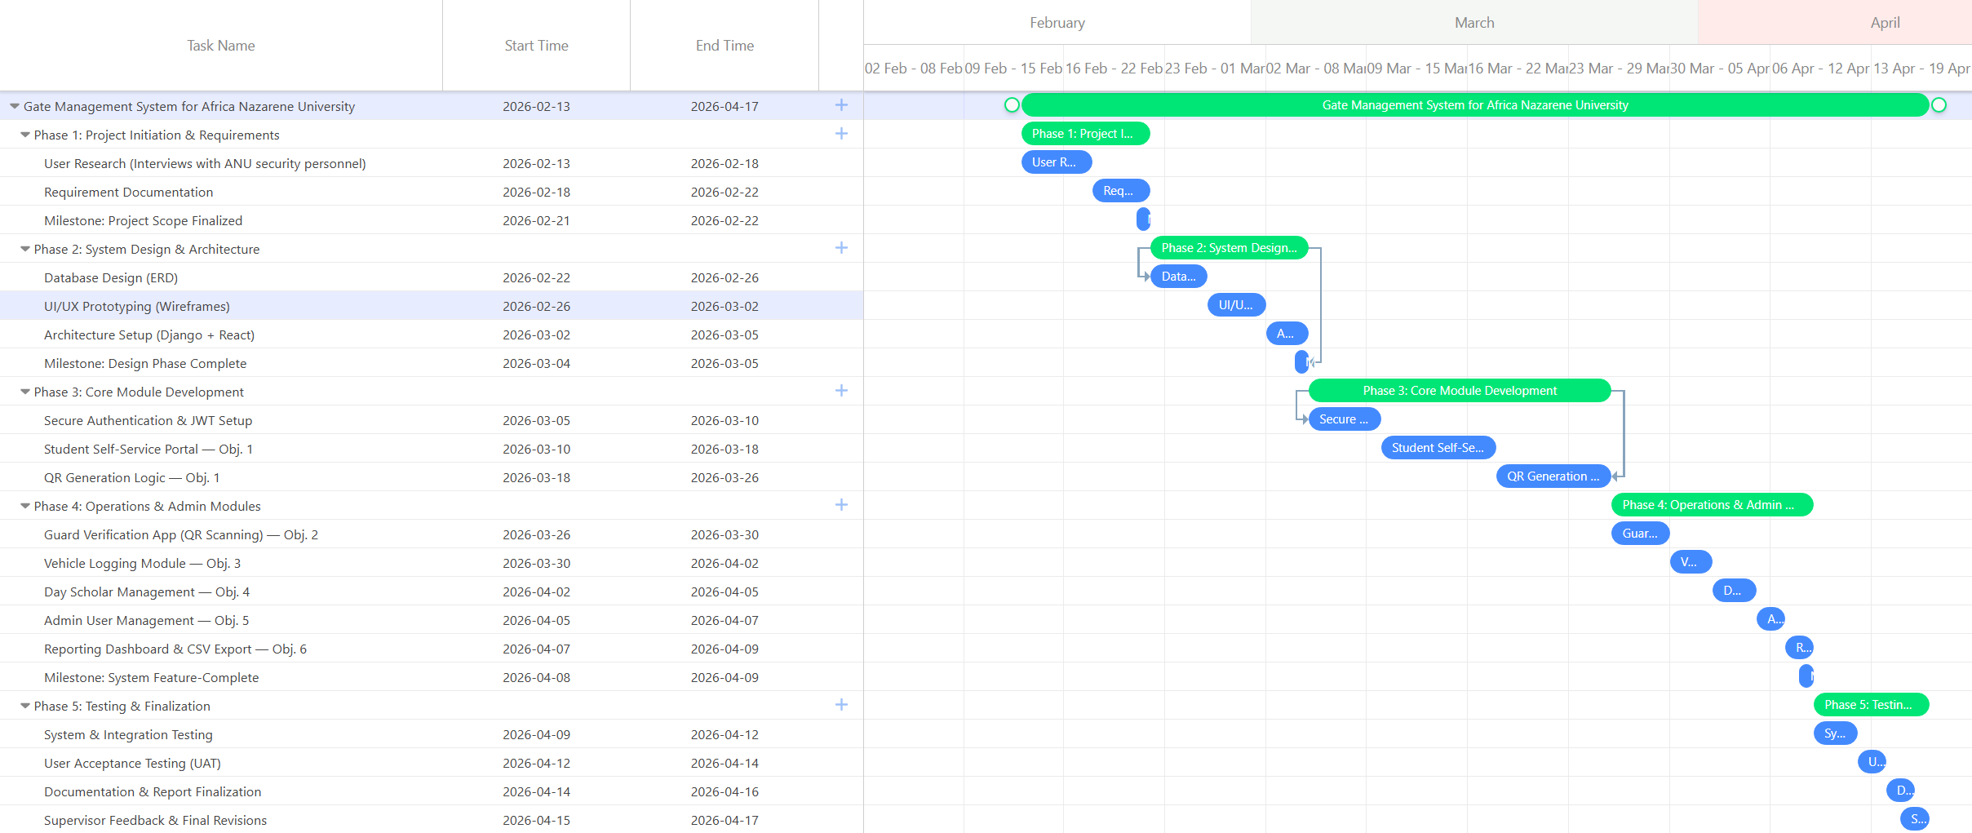

3.5. Budget

The project is designed to be highly cost-effective by leveraging open-source software and existing hardware.
Table 3 Budget
Item | Description | Estimated Cost (KES) | Justification
Software | Python, Django, React, PostgreSQL, etc. | 0 | All key software components are open-source.
Hardware | Development & testing Computer | 0 | Using existing computer.
Hosting | Local development server | 0 | The system was developed and tested on a local machine using Django's built-in development server. No external hosting was required.
Contingency | Miscellaneous (e.g., printing) | 0 | No unforeseen expenses were incurred.
Total |  | 0

3.6. Ethical Considerations

The development and implementation of this system necessitate careful consideration of ethical principles, particularly concerning data privacy and security.
- Data Privacy and Confidentiality: The system will handle Personally Identifiable Information (PII), including student names, ID numbers, vehicle license plates, and laptop serial numbers. The methodology will ensure all data is handled in accordance with data protection principles. The database will be secured, and access to the system will be strictly role-based.
- Informed Consent: All individuals participating in the research phase (interviews, UAT) will be fully informed about the project's purpose. Written informed consent will be obtained, ensuring they understand their participation is voluntary.
- Data Security: The system will be designed with robust security measures, including password hashing for all user accounts and secure JWT-based authentication for all API endpoints. Anonymized or synthetic data will be used for development and testing.

3.7. Conclusion

This chapter has detailed a comprehensive and structured methodology for the project. The selection of an Agile approach provides flexibility, while the mixed-methods requirements gathering ensures the system is grounded in user needs. The chosen technology stack (Python/Django and React.js) offers a modern, powerful, and feasible path for implementing the system's core functionalities. This methodology provides a clear roadmap for achieving the project's objectives and answering the guiding research questions.

Chapter 4: System Design
The following functional requirements were identified through stakeholder interviews and observation of the existing manual gate process. They define what the system must do for each user role.

4.1 Functional Requirements
The system will be designed to perform the following functional requirements:
- User Management (Admin): The Administrator (Security Manager) can create, read, update, and delete accounts for Guards and Students via the Django Admin Panel.
- User Authentication: All users (Student, Guard, Admin) must log in with a secure, password-protected account.
- Asset Registration (Student): A logged-in Student is able to register their assets (e.g., laptop, tablet) by providing a serial number and model.
- Vehicle Registration (Student): A logged-in Student is able to register their vehicle(s) by providing a plate number, make, model, and color.
- QR Code Generation (System): The system automatically generates a unique QR code for each registered asset.
- Asset Verification (Guard): A logged-in Guard can scan an asset's QR code using a web app and instantly see the asset's details and the owner's name and photo.
- Vehicle Logging (Guard): A logged-in Guard can manually enter a vehicle's plate number. The system searches the database and displays the registered owner's details or marks the vehicle as "Visitor." The guard then logs the entry or exit.
- Day Scholar Management (Guard): A logged-in Guard can view a list of all day scholars, mark them as "Signed Out" or "Signed In," and view a real-time list of who is currently on/off campus.
- Visitor Management (Guard): The system allows guards to record visitor names, National ID numbers, and the purpose of their visit.
- Reporting (Admin): The Administrator can view and filter all gate logs (vehicle, day scholar) by date, time, student, and guard, and export these logs.

4.1.1. Use Case Diagram
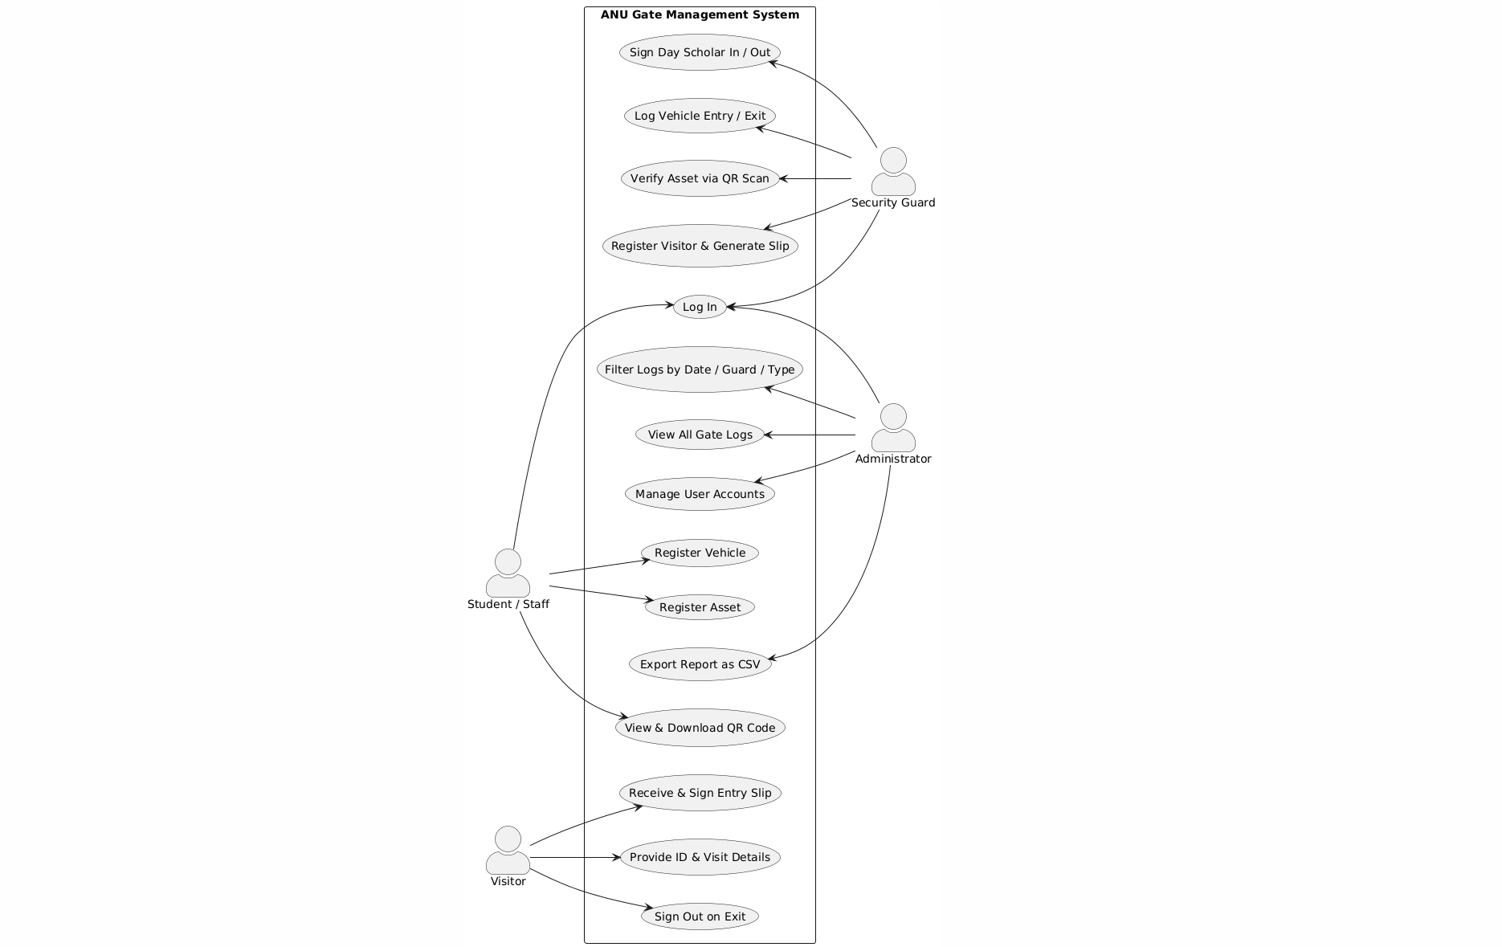
Figure 1: Use Case Diagram

4.2 Non-functional requirements
- Performance: All verifications (QR scan, plate lookup) return a result in under 3 seconds.
- Usability: The guard's interface is intuitive, with large touch targets and high contrast for outdoor visibility.
- Reliability: The system has an uptime of 99.9%. All log entries are transactional to prevent data loss.
- Security: All user passwords are hashed. All communication between the frontend and backend are over HTTPS and authenticated using JSON Web Tokens (JWT).
- Maintainability: The code is modular, well-commented, and use the standard Django and React project structures.

4.3 Context Diagram
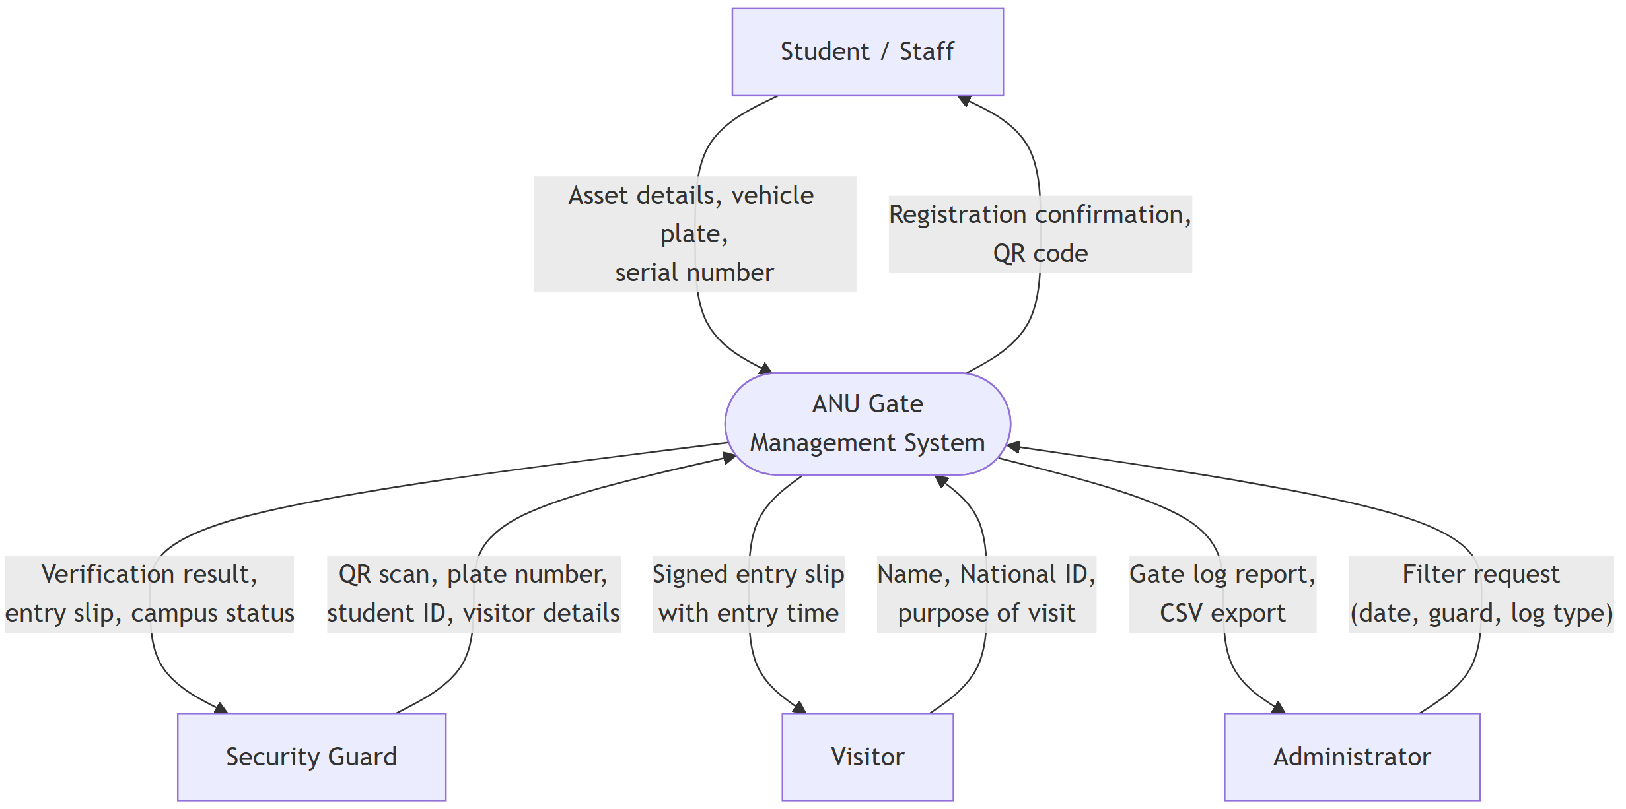
Figure 2: Context Diagram

4.4 Data Flow Diagram (DFD) Level 0
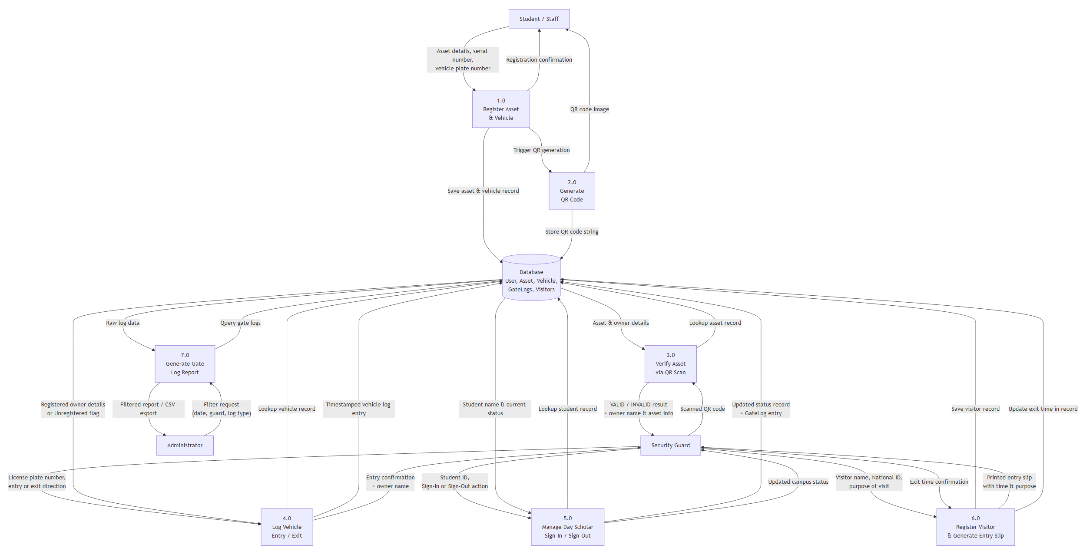
Figure 3: Data Flow Diagram

4.5 Class Diagram

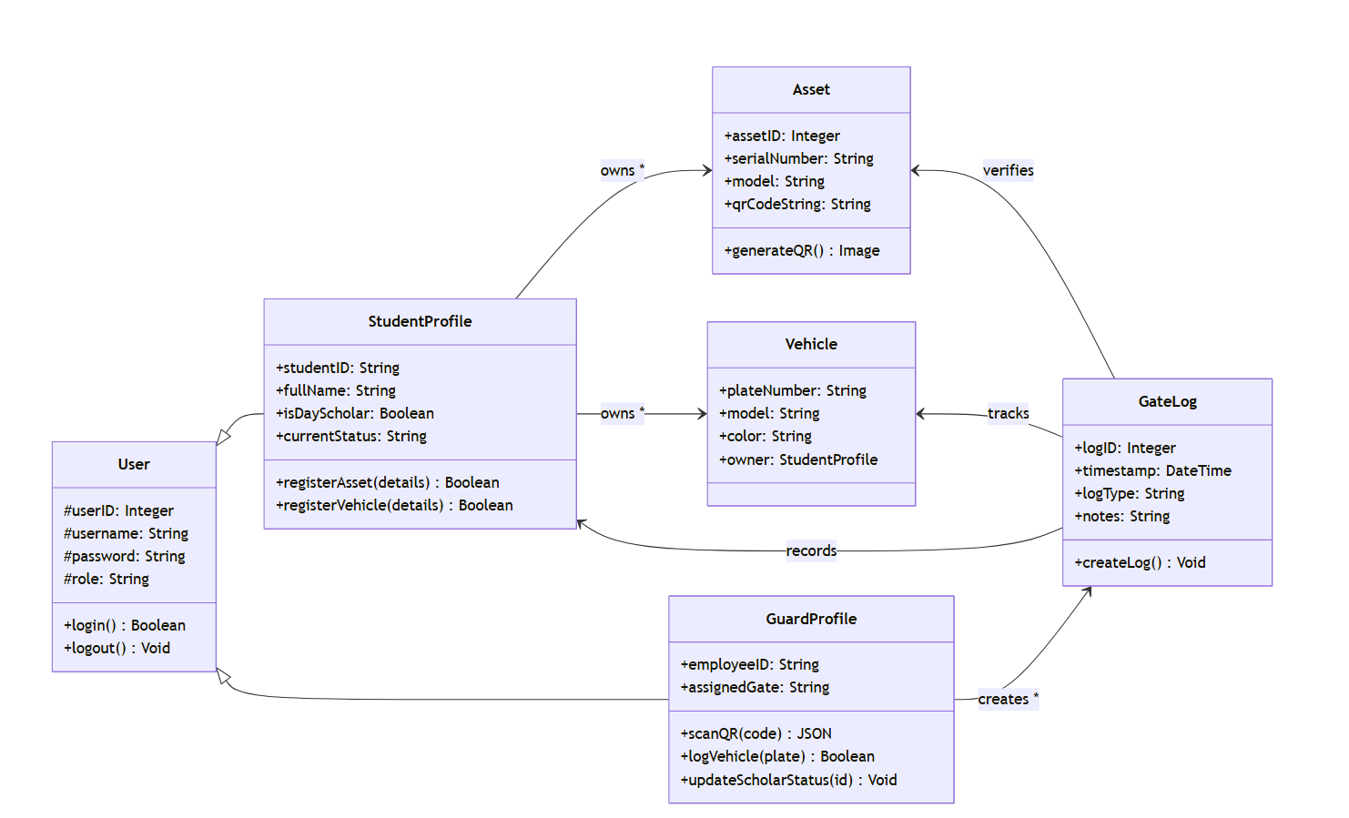
Figure 4: Class Diagram

4.6 Entity Relationship Diagram
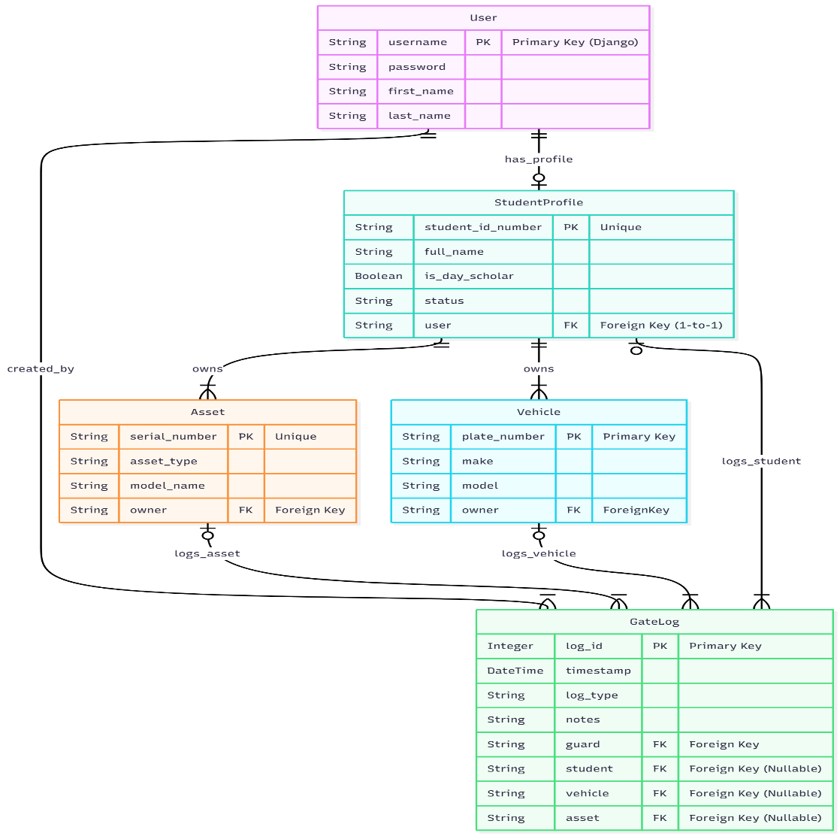
Figure 5: Entity Relationship Diagram

Chapter 5: System Implementation, Conclusion, and Recommendations

5.1 Introduction
This chapter presents the realized "Africa Nazarene University Gate Management System," documenting its technical architecture, core functional modules, and user interfaces. It provides a detailed account of how the system operates in a live environment to solve the fragmentation and security vulnerabilities of the previous manual processes. Finally, this chapter evaluates the system against the initial project objectives and offers recommendations for future institutional scaling.

5.2 System Architecture and Technical Stack
The system is implemented as a modern, decoupled web application designed for high performance and mobile-first accessibility at the campus gates.
- Backend: Developed using the Django REST Framework (Python), which handles business logic, role-based access control (RBAC), and secure API endpoints
- Frontend: A responsive React.js Progressive Web App (PWA) serves as the user interface. The PWA architecture ensures that the system is fast, reliable, and can be "installed" on guard mobile devices for quick access.
- Database: A PostgreSQL relational database is used for robust, scalable data storage of user profiles, asset records, and encrypted gate logs.
- Verification Engine: The system utilizes the html5-qrcode library to leverage device cameras for real-time QR code scanning and verification.

5.3 Functional Modules and User Interaction
The system provides tailored interfaces for three distinct user roles, ensuring that security workflows are streamlined and data capture is effortless.

5.3.1 Student and Staff Interaction
The primary interaction for students and staff occurs through a self-service dashboard where they manage their personal property.
- Asset Registration: Students navigate to the "Register New Asset" page and provide details such as Asset Type and Serial Number. The system validates and links this asset to the student's profile.
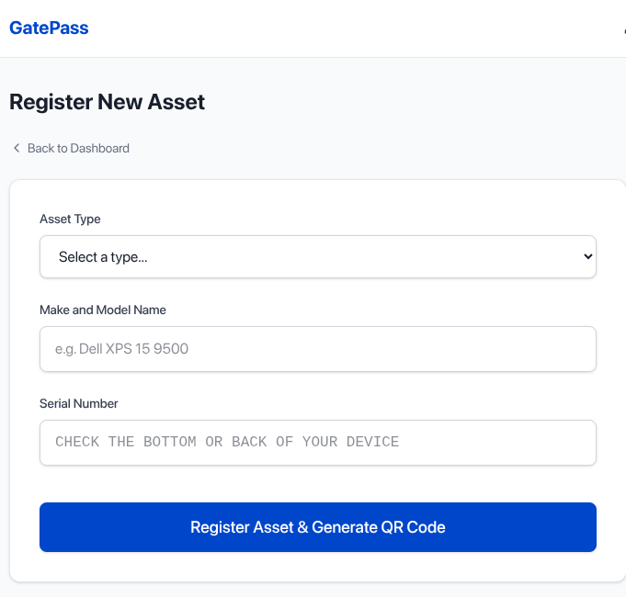
Figure 6: Asset Registration Form
- Credential Management: Upon registration, the system generates a unique, scannable QR code for every asset. Users can view, download, or print these credentials for gate verification.
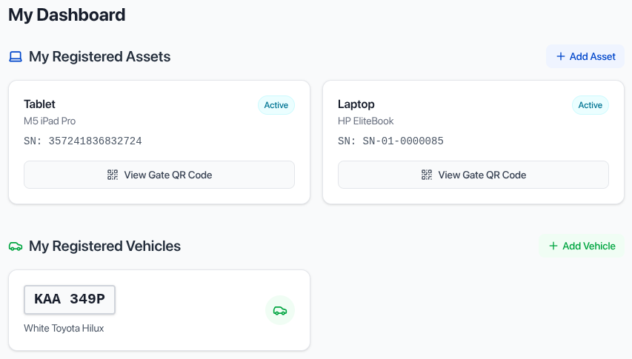
Figure 7: Dashboard with registered assets

5.3.2 Guard Operations Module
The guard interface is optimized for high-traffic environments, prioritizing speed and clarity.
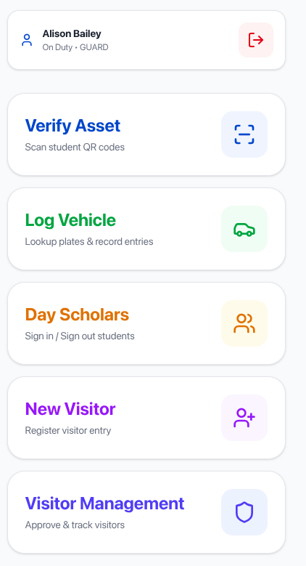
Figure 8: Guard action and options

- Contactless Asset Verification: Using the "Verify Asset" feature, guards scan an asset's QR code. The system provides an instant visual status: Green for a valid match (displaying owner details and photo) or Red for an invalid or missing record.

Figure 9: Asset verification
- Digital Vehicle Logging: Guards log vehicle movements by entering license plate numbers. The system automatically identifies registered owners or flags the vehicle as a visitor, creating a timestamped entry in the gate log in under five seconds.
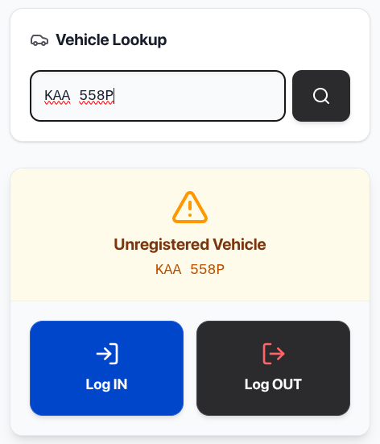
Figure 10: Vehicle verification

- Day Scholar Management: Replacing the traditional paper sign-out book, this module allows guards to update student campus status with a single tap. The interface maintains a real-time list of students currently on or off-campus.
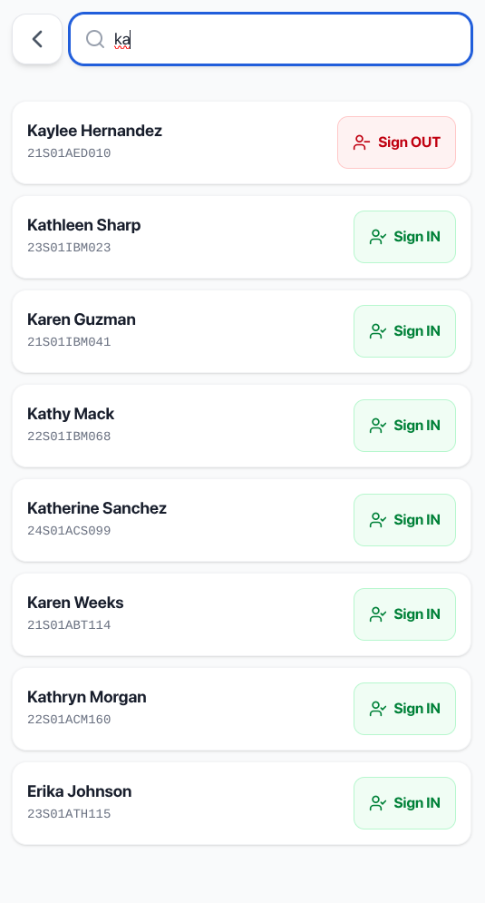
Figure 11: Day scholar Management

5.3.3 Administrative Oversight and Reporting
The Security Manager accesses a central dashboard via the Django Admin Panel to oversee campus activity.
- Audit Trails: The administrator can view a comprehensive table of all gate events, including timestamps, the guard on duty, and the specific nature of the log.
- Reporting and Analytics: The system provides built-in filters to sort logs by date, event type, or specific personnel. These filtered datasets can be exported as CSV files for official security audits and incident analysis.
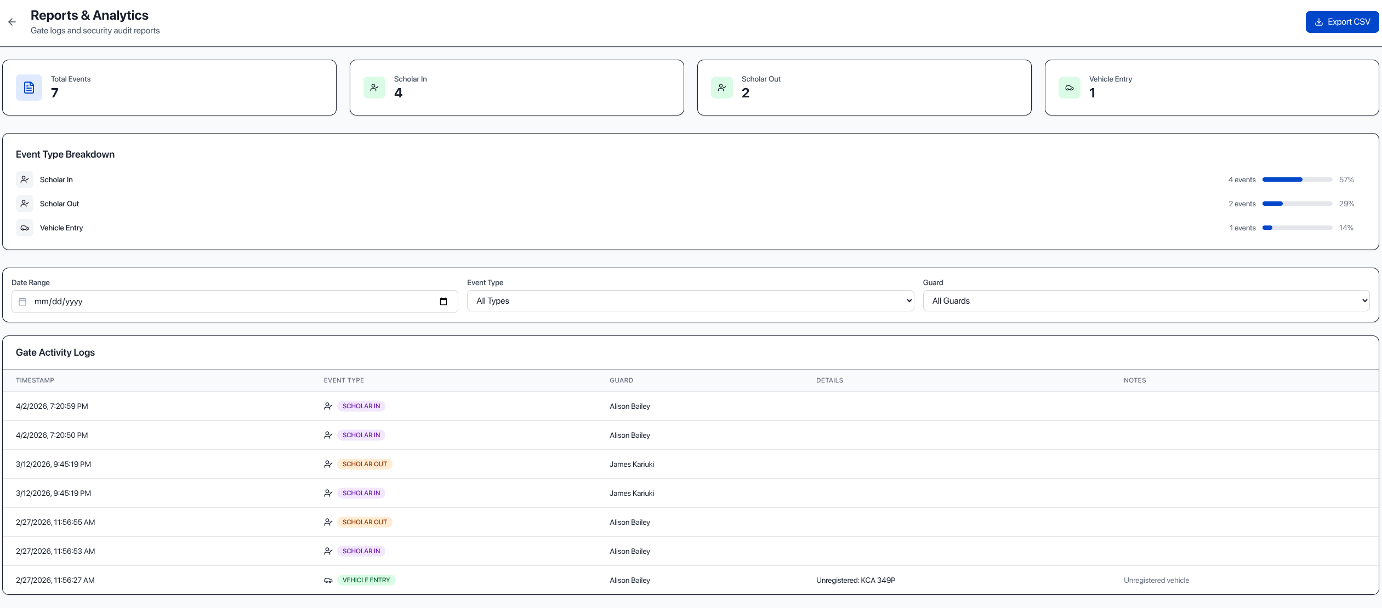
Figure 12: Administrator Dashboard (View Logs)

5.4 Evaluation of Project Objectives
The implemented system successfully fulfills the six core objectives established at the project's inception:
Objective | Achievement Status | Evidence
- Asset & Vehicle Registration with QR Code | Achieved | Functional registration forms for assets and vehicles; unique QR code automatically generated and downloadable per asset.
- Visitor Management & Entry Slip Generation | Achieved | Guard interface captures visitor name, ID, and purpose of visit; system generates a signed entry slip with entry and exit timestamps.
- Vehicle Logging by Plate Number | Achieved | Digital manual-entry module identifies registered owners or flags unknown vehicles and creates a timestamped gate log entry in under five seconds.
- Digital Day Scholar Sign-In/Out | Achieved | Real-time status toggle replacing the physical logbook; guard updates student campus status with a single tap.
- Administrator User Account Management | Achieved | Django Admin Panel allows administrators to create, update, and deactivate guard and student profiles with full CRUD control.
- Gate Log Reporting & Export | Achieved | Centralized dashboard with filtering by date, guard, and event type, plus CSV export for security audits.

The complete source code of this application is available at https://github.com/brandonthis-that/GatePass.git

5.5 Conclusion
The ANU Gate Management System successfully addresses the core problems of manual, fragmented verification. By unifying asset tracking, vehicle logging, and day scholar management into a single digital platform, the university can now eliminate long queues, prevent the bypass of security via forged documents, and maintain an auditable trail of all movements. The transition from paper ledgers to a React-Django PWA represents a significant upgrade in the university’s security posture and operational efficiency.

5.6 Recommendations
To further enhance the system, the following improvements are recommended for future phases:
- Offline Synchronization: Enhance the PWA to allow guards to log data during internet outages and automatically sync with the server once connectivity is restored.
- SIS Integration: Integrate directly with the university’s Student Information System (SIS) to automatically sync student profiles and photos.
- ANPR Integration: Implement Automatic Number Plate Recognition (ANPR) cameras to automate the vehicle logging module, further reducing the manual workload for guards.
- Automated Barriers: Connect the system API to physical boom gates to automate entry for pre-approved vehicles.

References

Ademola, J., & Mtonyi, J. (2020). A review of automatic number plate recognition systems for vehicle access control in South African universities. Journal of Information Systems Engineering & Management, 5(3), 1-12.
Afolabi, A., Oteze, P., & Ojo, S. (2023). Development of a QR code-based authentication system for managing student access to examination halls. International Journal of Computer Science and Information Security, 21(4), 88-95.
Appinventiv. (2025). How smart campuses are redefining the future of education. Retrieved November 7, 2025, from https://appinventiv.com/blog/smart-campus-technology-for-higher-education/
Django Software Foundation. (2024). About Django. Retrieved November 7, 2025, from https://www.google.com/search?q=https://www.djangoproject.com/about/
Genetec. (2025). Unified security for education. Retrieved November 7, 2025, from https://www.genetec.com/solutions/industries/education
Githinji, S., & Kanga, A. (2021). Effect of emergency preparedness on security in Kenyan universities: A case study of Garissa University. International Journal of Development and Management Review, 16(1), 45-58.
HID Global. (2025). Access & identity security solutions for universities. Retrieved November 7, 2025, from https://www.hidglobal.com/industries/universities
Inteconnex. (2024). University campus security system | Case Study. Retrieved November 7, 2025, from https://inteconnex.com/portfolio/university-campus-security-system/
Meta Platforms, Inc. (2024). React – A JavaScript library for building user interfaces. Retrieved November 7, 2025, from https://react.dev/
Ombui, V., Okeyo, G., & Mwangi, E. (2023). Multifactor authentication requirements for academic credential verification in Kenyan universities. International Journal of Research in Engineering and Science, 11(7), 134-142.
University of Nairobi. (2024). Security and safety services. Retrieved November 7, 2025, from https://mombasa.uonbi.ac.ke/basic-page/security-and-safety-services

